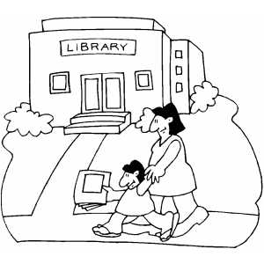
Bahasa Indonesia: Kata-kata Berguna (Useful Words)
Term 4, 2015

Topik: Di Kota
Topic: In the City

Tempat-tempat / Places | Preposisi / Prepositions
Bioskop Cinema  Kantor Pos Post Office  Kebun Binatang Zoo  Kolam Renang Swimming Pool  Pasar Market  Perpustakaan Library  Restoran Restaurant  Rumah Sakit Hospital  Sekolah School  Stasiun Kereta Api Train Station  Taman Park  Toko Shop | Di mana … ? Where is …?  Ie. Di mana sekolah? Where is the school?  Dekat Near  Di sebelah kanan On the right  Di sebelah kiri On the left  Di antara In between  Di depan In front of  Di belakang Behind  Di sudut On the corner
Pertanyaan / Questions | Alamat-Alamat / Addresses
Question: Di mana anda tinggal?  Where do you live?  Answer: Saya tinggal di ….  I live in …  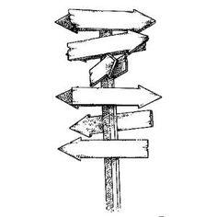  Question: Mau ke mana?  Where do you want to go?  Answer: Saya mau ke …  I want to go to … | In Indonesia, street addresses are  written in this format:  Jalan Scotsburn, Nomor 71  Endeavour Hills 3802  Jalan is the word used for any kind of road.  It can be shortened to Jl.  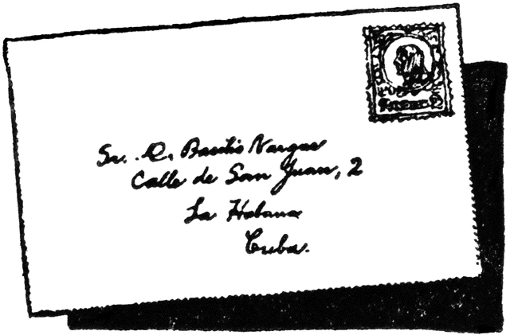
Asking for help! | Indonesian Number System
Permisi Excuse me  Pak Mr / Sir  Bu Miss / Mrs / Ms / Maam  Terima Kasih Thank you  Sama-sama You are welcome  Ie. Permisi Pak, di mana pasar? | Belas – used after a number to make teens  Puluh – used after a number to make tens  Ratus – used after a number to make hundreds  Ribu – used after a number to make thousands  Juta – used after a number to make millions  Note: se- takes the place of satu in 10, 11, 100, 1000, 1,000 000 etc.

